A

MAJOR PROJECT REPORT
(SYNOPSIS)

ON

“Smart Food Safety & Nutrition Tracker”



This Project Report is submitted to

Rajiv Gandhi Proudyogiki Vishwavidyalaya

in the partial fulfillment for the award of the degree of

Bachelor of Technology
VIII SEM
(Computer Science & Engg.)

Submitted By:

Lavkush Patel (0228CS221087)
Laxmi Prasad Rajbhar (0228CS221088)

Under the guidance of:

Prof. Nitin Shukla

Head of Department

Computer Science
SHRI RAM GROUP OF INSTITUTIONS (SRGI)

SHRI RAM GROUP OF INSTITUTIONS (SRGI), JABALPUR
2026

Approved by AICTE New Delhi & Govt. of M.P.
(Affiliated to R.G.P.V. - University of Technology of Madhya Pradesh)

CERTIFICATE
This is to certify that,

Lavkush Patel (Enrol No.: 0228CS221087)
Laxmi Prasad Rajbhar (Enrol No.: 0228CS221088)

Students of the 8th Semester, Computer Science & Engineering, SHRI RAM GROUP OF INSTITUTIONS (SRGI), Jabalpur, have submitted their major project synopsis entitled “Smart Food Safety & Nutrition Tracker” for the completion of the 8th semester examination under the requirement for the degree of Bachelor of Technology as per R.G.P.V., Bhopal (M.P.).

This is an original work of these students and is based on their own innovative idea. We hereby certify that this project is an authentic work by these young minds.

Prof. Nitin Shukla
Head- Computer Science Dept. S.R.G.I.

Approved by AICTE New Delhi & Govt. of M.P.
(Affiliated to R.G.P.V.- University of Technology of Madhya Pradesh)

CERTIFICATE OF APPROVAL

The foregoing major project title, “Smart Food Safety & Nutrition Tracker”, is hereby approved as a creditable study of an engineering subject carried out and presented in a manner satisfactory to warrant its acceptance as a prerequisite to the degree for which it has been submitted. It is understood that by this approval, the undersigned does not necessarily endorse or approve any statement made, opinion expressed, or conclusion drawn therein, but approves the project only for the purpose for which it has been submitted.

(Internal Examiner) (External Examiner)

Approved by AICTE New Delhi & Govt. of M.P.
(Affiliated to R.G.P.V. - University of Technology of Madhya Pradesh)

DECLARATION

Here we declare that the project entitled which is being submitted in partial fulfillment of the requirement for the award of the degree of Bachelor of Technology in Computer Science “RAJIV GANDHI PROUDYOGIKI VISHWAVIDYALAYA, BHOPAL [M.P]” is the authentic record of my own work done under the guidance of Prof. Nitin Shukla [HOD -Computer Science Dept].
The Matter reported in this project has not been submitted earlier for the award of a degree.

PLACE: JABALPUR STUDENT NAME:
DATE: Lavkush Patel (0228CS221087)
Laxmi Prasad Rajbhar (0228CS221088)

Approved by AICTE New Delhi & Govt. of M.P.
(Affiliated to R.G.P.V. - University of Technology of Madhya Pradesh)

FORWARD

I hereby forward the project title “Smart Food Safety & Nutrition Tracker”, which is being submitted by:
Lavkush Patel (0228CS221087)
Laxmi Prasad Rajbhar (0228CS221088)

In partial fulfilment of the requirement for the award of the Degree of Bachelor of Technology in Computer Science, “Rajiv Gandhi Proudyogiki Vishwavidyalaya Bhopal [M.P]”

PLACE: JABALPUR Prof. Nitin Shukla HOD
DATE: Computer Science & Engg. Department
SHRI RAM GROUP OF INSTITUTIONS (SRGI) JABALPUR [M.P]

Approved by AICTE New Delhi & Govt. of M.P.
(Affiliated to R.G.P.V. - University of Technology of Madhya Pradesh)

ACKNOWLEDGEMENTS

We would like to extend our gratitude to all those who gave us the possibility to complete this project. We would like to thank the Department of Computer Science of SHRI RAM GROUP OF INSTITUTIONS (SRGI) for permitting us to commence this project in the first instance, to do the necessary research and to use departmental accessories.
We are deeply indebted to our supervisor Prof. Nitin Shukla [HOD -Computer Science Dept], whose help, insightful suggestions and encouragement helped us at all times in completing this project.

We are bound to our honourable head of the department, Prof. Nitin Shukla, for his simulating support. We have furthermore to thank the Faculty of our college, who helped us in providing the necessary data.
Our former colleagues in the department also supported us in our project. We want to thank them for all their help, support, interest and valuable hints.

PLACE: JABALPUR STUDENT NAME:
DATE: LAVKUSH PATEL (0228CS221087)
LAXMI PRASAD RAJBHAR (0228CS221088)

INDEX

Chapter 1 | INTRODUCTION | 1–5
 | 1.1 Introduction | 1
 | 1.2 Problem Statement | 2
 | 1.3 Project Objectives & Goals | 3
 | 1.4 Scope and Limitations | 4
 | 1.5 Report Outline | 5
Chapter 2 | LITERATURE SURVEY | 6-7
 | 2.1 Survey and Analysis of Existing Solutions | 6
 | 2.2 Identification of Research Gap | 7
Chapter 3 | REQUIREMENT ANALYSIS AND SPECIFICATION | 8–10
 | 3.1 Functional Requirements | 8
 | 3.2 Non-Functional Requirements | 9
 | 3.3 Software and Hardware Requirements | 10
Chapter 4 | SYSTEM DESIGN AND ARCHITECTURE | 11–17
 | 4.1 System Architecture Diagram | 11
 | 4.2 Database Design (Entity-Relationship Diagram, Schema) | 12
 | 4.3 Model Design (Flowcharts, Pseudocode) | 13-14
 | 4.4 DFD Diagrams | 15-16
 | 4.5 Use Case Diagrams | 17
Chapter 5 | IMPLEMENTATION, TESTING, AND MAINTENANCE | 18-22
 | 5.1 Introduction to Languages, IDE | 18
 | 5.2 Tools and Technologies used for Implementation | 19
 | 5.3 Coding standards of Language used in Project Scheduling using various tools such as PERT, GANTT charts, Open PROJ, etc. | 20
 | 5.4 Testing Techniques and Test Plans | 22
Chapter 6 | EXPECTED RESULTS AND DISCUSSION | 23
 | 6.1 Expected Results and Discussion | 23
 | 6.2 Expected Performance Results | 23
Chapter 7 | CONCLUSION | 24
 | 7.1 Conclusion | 24
 | REFERNECES | 24
APPENDICES | Appendix A: Source Code (GitHub Repository Link and Snapshot)  Appendix B: Comprehensive Project Timeline (Gantt Chart)  Appendix C: Team Member Contributions  Appendix D: Dataset Details and Sources  Appendix E: Relevant Published Papers | 25-26  26  27  27  27

CHAPTER 1
INTRODUCTION

1.1 INTRODUCTION
In the modern era, people are increasingly concerned about their health due to rising lifestyle diseases such as obesity, diabetes, and heart-related problems. However, most individuals lack proper awareness of nutritional values and harmful ingredients present in processed foods.
To address this issue, the Smart Food Safety and Nutrition Tracker system is proposed. It provides users with essential nutritional information, including calories, protein, carbohydrates, fats, sugar, sodium, vitamins, and minerals. It also analyses food safety by detecting harmful ingredients, preservatives, trans fats, and excessive sugar or sodium.
The system allows users to scan or search food products using a barcode or product name. It retrieves data from a database or API and generates a nutritional summary along with a health score. This helps users quickly understand the health impact of food items.
The system simplifies complex data into an easy-to-understand format and provides recommendations such as healthy, moderate, or avoid.
The architecture is modular and scalable, allowing future improvements like personalised recommendations and AI-based analysis.
Overall, the system helps users make healthier food choices by providing real-time and simplified nutritional insights.

1.2 PROBLEM STATEMENT
The Smart Food Safety and Nutrition Tracker addresses the growing concern of unhealthy dietary habits caused by increased consumption of packaged, processed, and fast foods. In modern lifestyles, individuals often rely on convenience foods that contain complex ingredient compositions, including artificial additives, preservatives, excessive sugar, sodium, and unhealthy fats. These components are difficult for average users to interpret, leading to unintentional consumption of unhealthy food products. Over time, this contributes to serious health issues such as obesity, diabetes, cardiovascular diseases, and nutritional deficiencies.
A major challenge is the lack of proper awareness and understanding of nutritional information. Although food products provide nutritional labels, the data is often technical and difficult to interpret, especially for non-technical users. This creates a gap between available information and the user's understanding of macronutrients and micronutrients.
Another key issue is the absence of a unified system that integrates both nutritional analysis and food safety evaluation. Existing solutions typically focus on either calorie tracking or diet planning, but fail to provide a comprehensive assessment of food safety risks such as harmful ingredients, preservatives, and excessive nutrient levels.
Additionally, most existing systems do not support real-time automated food identification and require manual data entry, which reduces usability and increases the chances of errors. Furthermore, there is limited personalisation in dietary recommendations based on user health conditions and lifestyle factors.
Therefore, there is a need for an intelligent system that can automatically identify food products, analyse nutritional composition, evaluate safety risks, and provide real-time personalised dietary recommendations.

Problem Statement:
To design and develop a Smart Food Safety and Nutrition Tracker system that automatically analyses food products, extracts nutritional information, evaluates health risks, and provides personalised dietary recommendations in a simple, efficient, and real-time manner.

1.3 Project Objectives & Goals

The objective of the Smart Food Safety and Nutrition Tracker is to design an intelligent system that enables users to analyse the nutritional composition and safety of food products in an efficient and structured manner. The system addresses the growing need for informed dietary decisions due to increasing lifestyle-related diseases such as obesity, diabetes, and hypertension.

The primary objective is to perform accurate nutritional analysis of food products by extracting and presenting key parameters such as calories, proteins, carbohydrates, fats, sugar, sodium, vitamins, and minerals in a standardised format for easy interpretation.

Another key objective is to evaluate food safety by analysing ingredients and identifying harmful components such as artificial preservatives, trans fats, excessive sugar, and high sodium levels. Based on this, a health risk score or classification is generated to indicate the safety level of the food item.

The system also supports real-time food information retrieval using barcode scanning or product search, enabling quick and efficient access to food details. In addition, a personalisation module provides dietary recommendations based on user attributes such as age, weight, lifestyle, and medical conditions.

Furthermore, the system simplifies complex nutritional data into interpretable formats such as health scores, warnings, and categorised labels to improve usability and decision-making.

Overall Objectives

To analyse the nutritional composition of food products

To detect harmful ingredients and evaluate food safety

To enable real-time food scanning and information retrieval

To generate personalised dietary recommendations

To present nutritional data in simplified and user-friendly formats

1.4 SCOPE AND LIMITATIONS
The Smart Food Safety and Nutrition Tracker is an intelligent system designed to analyse food products, evaluate their nutritional content, and provide safety-related insights to users. The project has a significant scope in health informatics, artificial intelligence, and data-driven nutrition analysis, aiming to promote healthier dietary habits and improve public health awareness.

Scope of the Project
The system is primarily applicable in personal health management, where users can monitor nutritional intake and make informed dietary decisions. It also supports preventive healthcare by helping reduce the risk of lifestyle diseases such as diabetes, obesity, and hypertension through food safety evaluation and nutritional awareness.
Additionally, the system is useful for fitness and diet planning applications, assisting users such as gym-goers, athletes, and nutritionists in tracking calories, protein intake, and overall diet quality. It can also be integrated into educational platforms to promote awareness about nutrition and healthy eating habits.
From a technical perspective, the system can be extended using artificial intelligence and machine learning techniques to improve food recognition accuracy and enable more personalised dietary recommendations. Future integration with mobile and wearable devices can further enhance real-time health monitoring capabilities.

Limitations of the Project
The system depends heavily on the availability and accuracy of food databases; incomplete or incorrect data may affect results. Real-time food recognition may also be influenced by environmental factors such as lighting conditions, image quality, and camera performance.
In addition, computational requirements for advanced AI models may limit performance on low-end devices. The system provides generalised recommendations and cannot replace professional medical or dietary consultation. Its effectiveness also depends on consistent and accurate user input.

1.5 REPORT OUTLINE
This section presents the structured organisation of the project report. The report is divided into multiple chapters covering system development from requirement analysis to final evaluation, ensuring a clear and systematic flow of information.
Chapter 1: Introduction
This chapter includes the background, problem statement, objectives, scope, and limitations of the system. It explains the need for a smart nutrition analysis solution due to increasing health concerns and a lack of awareness about food composition.
Chapter 2: Literature Survey
This chapter reviews existing systems and research in nutrition tracking and food analysis. It identifies key limitations such as a lack of real-time processing, limited personalisation, and insufficient food safety evaluation, which are addressed in the proposed system.
Chapter 3: Requirement Analysis
This chapter defines functional and non-functional requirements. Key features include barcode scanning, food search, nutrition display, and health score generation. It also includes system requirements related to performance, usability, and scalability.
Chapter 4: System Design
This chapter describes the system architecture, module interaction, and design models such as DFD and use case diagrams. It explains how data is collected, processed, and presented to the user.
Chapter 5: Implementation and Testing
This chapter covers development tools, technologies, and testing methods used to ensure system accuracy, reliability, and performance.
Chapter 6: Results and Conclusion
This chapter summarises expected results, including nutritional analysis, safety evaluation, and personalised recommendations. It also highlights system effectiveness in improving dietary awareness.
Appendices

CHAPTER 2
LITERATURE SURVEY
2.1 SURVEY AND ANALYSIS OF EXISTING SOLUTIONS
In the domain of food nutrition analysis and dietary tracking, several solutions and applications already exist, primarily focusing on calorie counting, diet tracking, and basic nutritional information. However, a detailed study of these systems highlights several limitations, indicating the need for a more intelligent and integrated solution.
Existing mobile-based calorie tracking applications allow users to manually enter food items or select from a database to obtain nutritional information. While useful, these systems heavily depend on manual input, making them time-consuming and prone to human error.
Barcode-based food tracking systems improve usability by enabling quick scanning of packaged foods. However, they are limited to packaged items and rely on the availability and accuracy of product databases.
AI-based diet recommendation systems provide personalised diet plans based on user profiles but generally lack real-time food recognition and detailed food safety analysis.
Some research-based systems use machine learning and computer vision for food recognition, but they often face challenges such as low accuracy, high computational requirements, and dependency on large datasets.
Cloud-based food nutrition APIs provide reliable nutritional data but do not offer intelligent analysis, safety evaluation, or personalised decision-making.

Key Limitations Identified
- Heavy dependence on manual data entry
- Lack of real-time intelligent analysis
- Limited support for non-packaged food items
- Absence of food safety evaluation
- Poor personalisation based on user health conditions

Conclusion of Survey
Existing systems provide partial solutions but fail to deliver a complete and intelligent dietary analysis platform. This highlights the need for an integrated system that combines real-time food recognition, nutritional analysis, food safety evaluation, and personalised recommendations.

2.2 IDENTIFICATION OF RESEARCH GAP
After analysing existing food nutrition tracking systems, barcode scanners, AI-based diet planners, and research models, it is observed that although significant progress has been made in dietary analysis and food recognition, several critical challenges still exist. These challenges define the research gap addressed by this project.
A major gap is the absence of a unified system that integrates both nutritional analysis and food safety evaluation. Most existing applications focus on either calorie tracking or diet planning, but do not provide a comprehensive solution that includes ingredient-level safety analysis along with nutritional breakdown.
Another key limitation is the lack of real-time intelligent processing. Current systems mainly rely on static database lookup (e.g., barcode scanning) and do not perform dynamic analysis such as health risk evaluation or safety scoring.
Personalisation is also limited in existing systems. Users receive generalised recommendations without considering individual health conditions, age, or dietary requirements, making the suggestions less effective.
Additionally, most systems do not perform detailed ingredient-level safety analysis to detect harmful substances such as trans fats, preservatives, excessive sugar, or sodium content.
AI-based food recognition models also face challenges such as low accuracy in real-world conditions, dependency on large datasets, and poor performance with complex or mixed food items.
Furthermore, nutritional information is often presented in raw numerical form, which reduces usability for non-technical users and lacks simplified interpretation methods.

Identified Research Gaps
- No unified system for nutrition + food safety analysis
- Lack of real-time intelligent decision-making
- Absence of personalised dietary recommendations
- Limited ingredient-level safety detection
- Low real-world accuracy in food recognition systems
- Poor user-friendly representation of nutritional data

Conclusion
These gaps highlight the need for an integrated and intelligent system. The proposed Smart Food Safety and Nutrition Tracker addresses these limitations by combining real-time food recognition, nutritional analysis, safety evaluation, and personalized recommendations into a single platform.
CHAPTER 3
REQUIREMENT ANALYSIS AND SPECIFICATION
3.1 FUNCTIONAL REQUIREMENTS
Functional requirements define the core features and behaviours that the Smart Food Safety and Nutrition Tracker system must provide to achieve its intended objectives.
The system must support food product identification through barcode scanning or manual search, enabling users to quickly retrieve product information.
It must display detailed nutritional information, including calories, proteins, carbohydrates, fats, sugar, sodium, vitamins, and minerals in a structured format for easy interpretation.
The system should perform food safety analysis by identifying harmful ingredients such as preservatives, artificial sweeteners, trans fats, and excessive sugar or sodium content, and generate a corresponding safety rating.
A health score generation module must evaluate each food item based on nutritional value and safety parameters to classify it as healthy, moderately safe, or unhealthy.
The system must support user profile management, allowing users to store personal details such as age, weight, health conditions, and fitness goals for personalised analysis.
Based on user profiles and food analysis, the system should provide personalised dietary recommendations and warnings.
It should also include search and filtering functionality to categorise food items based on dietary needs, such as low-calorie, high-protein, or diabetic-friendly options.
Additionally, the system must maintain a history of scanned or searched items to help users track their dietary habits.
Finally, the system must provide a simple and intuitive user interface to ensure ease of use for all types of users.

Summary of Functional Requirements
- Barcode scanning and product search
- Nutritional information display
- Food safety analysis
- Health score generation
- User profile management
- Personalised recommendations
3.2 NON-FUNCTIONAL REQUIREMENTS
Non-functional requirements define the quality attributes and performance characteristics of the Smart Food Safety and Nutrition Tracker system. These requirements ensure that the system operates efficiently, reliably, and securely.
The system should provide high performance with minimal response time, delivering results such as barcode scanning, food search, and health score generation in real-time or within a few seconds.
Accuracy is a critical requirement, ensuring that nutritional data and food safety analysis are reliable and based on updated and valid data sources. Incorrect or outdated information must be minimised.
Usability is essential, and the system should offer a simple and intuitive interface that allows users, including non-technical individuals, to easily access and understand nutritional insights.
The system must be reliable and stable, ensuring continuous operation without frequent failures or crashes, even under high usage conditions.
Scalability should be supported through a modular design, allowing future enhancements such as additional food databases, AI-based analysis, or increased user load.
Security is important for protecting user data, including personal profiles and health-related information, by using appropriate authentication and secure data handling techniques.
Maintainability ensures that the system can be easily updated, debugged, and extended without affecting existing functionality.
The system should also be compatible across multiple devices and platforms, including desktops and web-based environments.

Summary of Non-Functional Requirements
- High performance and real-time response
- High accuracy of nutritional and safety data
- Simple and user-friendly interface
- System reliability and stability
- Scalability for future expansion
- Strong data security and privacy
- Easy maintainability
- Cross-platform compatibility

3.3 SOFTWARE AND HARDWARE REQUIREMENTS
The Smart Food Safety and Nutrition Tracker system requires a combination of software tools and hardware components to ensure smooth development, deployment, and execution. These requirements define the technical environment in which the system operates and help in achieving optimal performance, accuracy, and usability.

Software Requirements
The software requirements include all the tools, programming languages, frameworks, libraries, and platforms used to develop the system.
- Operating System: Windows / Linux / macOS
- Programming Language: Python
- Frameworks: Flask / Django (Backend), HTML/CSS/JS / React (Frontend)
- Libraries: TensorFlow, Keras, Scikit-learn, OpenCV
- Database: MySQL / PostgreSQL / MongoDB
- APIs: Food Nutrition APIs, Barcode Scanner APIs
- Tools: VS Code / PyCharm, Jupyter Notebook, Git/GitHub, Postman

Hardware Requirements
The hardware requirements define the physical components needed to develop and run the system efficiently.
- Processor: Minimum i3, Recommended i5 or higher
- RAM: Minimum 4GB, Recommended 8GB+
- Storage: Minimum 256GB, SSD preferred
- Camera: Required for scanning
- GPU (Optional): For deep learning
- Internet: Required

Summary
The system uses standard hardware and modern software tools to ensure efficient, scalable, and real-time performance.

CHAPTER 4:
SYSTEM DESIGN AND ARCHITECTURE

4.1 SYSTEM ARCHITECTURE DIAGRAM
The system architecture defines the overall structure and interaction between different components of the Smart Food Safety and Nutrition Tracker. The system follows a modular architecture, where each component performs a specific function, ensuring scalability, flexibility, and easy maintenance.

Main Components
- User Interface (Frontend): Allows users to scan barcodes, search food items, and view results.
- Input Processing Module: Handles and validates user input (scan/search).
- Backend Server: Processes requests and manages communication between modules.
- Database / APIs: Stores and retrieves food data such as nutrition and ingredients.
- Nutrition Analysis Module: Analyses calories, proteins, fats, carbohydrates, etc.
- Food Safety Module: Detects harmful ingredients and evaluates safety levels.
- Health Score & Recommendation Engine: Generates health score and personalised suggestions.
- User Profile Database: Stores user details for personalised recommendations.

System Workflow
- User inputs data (barcode scan or search)
- Input is processed and sent to the backend
- Data is fetched from the database/API
- Nutrition and safety analysis is performed
- Health score is generated
- Results are displayed to the user
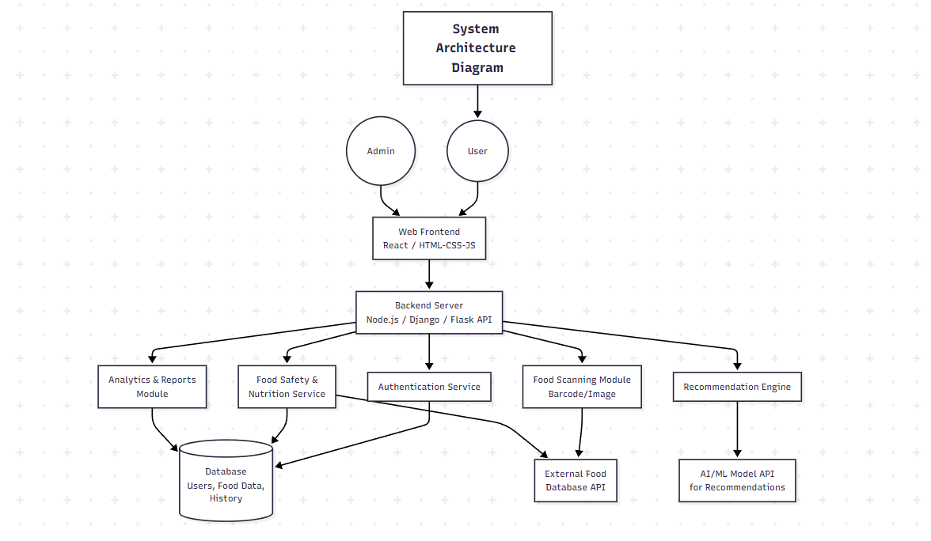

4.2 DATABASE DESIGN (E-R DIAGRAM, SCHEMA)
The database design manages all essential data related to users, food products, nutrition, and system interactions. It follows an Entity-Relationship (ER) model to ensure efficient data storage, consistency, and scalability.

Main Entities
- User: Stores user details (User_ID, Name, Age, Health_Conditions, Email)
- Food_Product: Stores product details (Product_ID, Name, Barcode, Brand)
- Nutritional_Info: Contains nutrition data (Calories, Protein, Carbs, Fats, Sugar, Sodium)
- Ingredients: Stores ingredients with risk level
- Health_Score: Stores score, risk level, and recommendation
- Scan_History: Stores user activity (User_ID, Product_ID, Date_Time)

Relationships
- User → Scan_History (1: M)
- Food_Product → Nutritional_Info (1: 1)
- Food_Product → Ingredients (1: M)
- Food_Product → Health_Score (1: 1)

Database Tables
- Users (user_id, name, age, health_conditions, email)
- Food_Products (product_id, name, barcode, brand)
- Nutrition (product_id, calories, protein, carbs, fats, sugar, sodium)
- Ingredients (product_id, ingredient_name, risk_level)
- Health_Score (product_id, score, risk_level, recommendation)
- Scan_History (user_id, product_id, date_time)
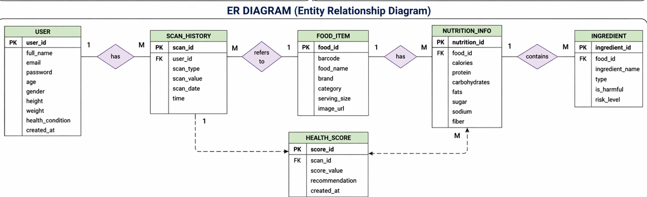

4.3 MODEL DESIGN (FLOWCHARTS, PSEUDOCODE)
The model design defines how the system processes user input, performs analysis, and generates output such as nutritional details, safety evaluation, and health score.

Flowchart (Working Steps)
- User inputs data (barcode scan/food name)
- Validate input
- Fetch data from database/API
- Extract nutritional values and ingredients
- Perform nutrition analysis (calories, protein, fats, etc.)
- Perform food safety analysis (sugar, sodium, harmful ingredients)
- Calculate health score
- Generate recommendation (Healthy / Moderate / Avoid)
- Display results
- Store in history

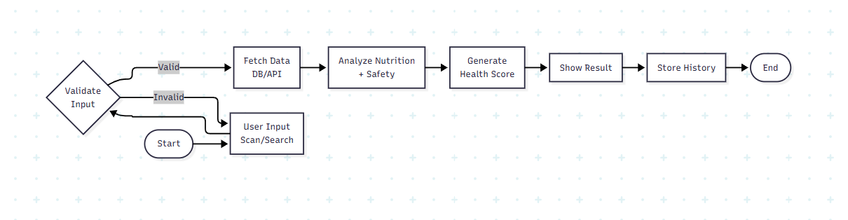

Pseudocode
START

INPUT user_input

IF input is valid THEN
FETCH food_data

IF data exists THEN
EXTRACT nutrition and ingredients

CALCULATE nutritional values

CHECK sugar level
CHECK sodium level
CHECK harmful ingredients

SET score = 100

IF sugar is high THEN
score = score - 20
ENDIF

IF sodium is high THEN
score = score - 15
ENDIF

IF harmful ingredients found THEN
score = score - 25
ENDIF

IF score >= 80 THEN
SET category = "Healthy"
ELSE IF score >= 50 THEN
SET category = "Moderate"
ELSE
SET category = "Avoid"
ENDIF

DISPLAY nutrition details
DISPLAY health category
STORE user history

ELSE
DISPLAY "Food not found"
ENDIF

ELSE
DISPLAY "Invalid input"
ENDIF

END

4.4 DFD DIAGRAMS (DATA FLOW DIAGRAMS)
Data Flow Diagrams (DFDs) represent how data flows within the system, including input, processing, storage, and output. They provide a clear understanding of system functionality.

1. Level 0 DFD (Context Diagram)
This level shows the system as a single process and its interaction with external entities.
- External Entities:
  - User
  - Food Database/API
- Data Flow:
  - User → System: Food input (scan/search)
  - System → Database/API: Data request
  - Database/API → System: Food data
  - System → User: Output (nutrition, safety, score)
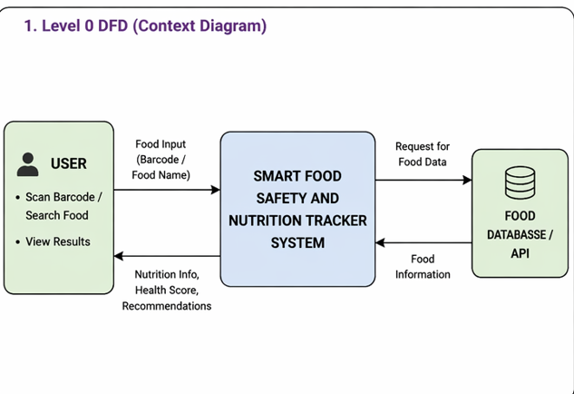

2. Level 1 DFD (Detailed View)
This level breaks the system into major processes:
- Processes:
  - Input Processing
  - Data Retrieval
  - Nutrition Analysis
  - Food Safety Analysis
  - Health Score Calculation
  - Recommendation System
  - Data Storage
- Data Stores:
  - User Database
  - Food Database
  - History Database
- Flow:
User Input → Input Processing → Data Retrieval →
(Nutrition + Safety Analysis) → Health Score →
Recommendation → Output → Store History
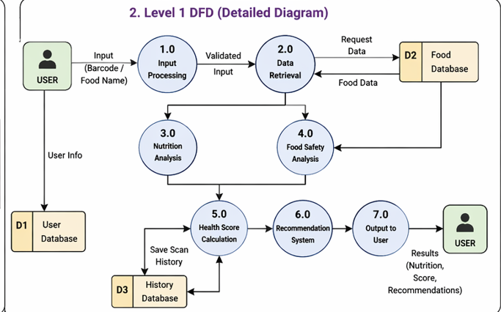

4.5 USE CASE DIAGRAMS

Use Case Diagrams represent the interaction between users (actors) and system functionalities, helping to define system behaviour from a user perspective.

Actors
- User (Primary Actor): Interacts with system features such as scanning, searching, and viewing results
- Admin (Optional): Manages database and system maintenance

Main Use Cases
- Register / Login
- Scan Food Product
- Search Food Item
- View Nutritional Information
- Food Safety Analysis
- View Health Score
- Get Recommendations
- Manage User Profile
- View Scan History
- Admin Management (optional)

Use Case Flow
User → Scan/Search Food → Fetch Data →
Analyze Nutrition & Safety → Generate Health Score →
Provide Recommendation → Display Result → Store History

Conclusion
The Use Case Diagram defines system functionalities and user interactions, ensuring a clear understanding and efficient system design.

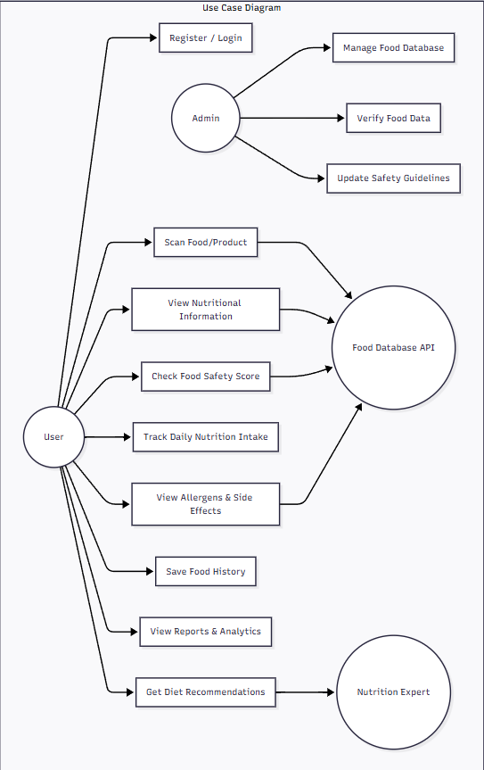

CHAPTER 5:
IMPLEMENTATION, TESTING, AND MAINTENANCE

5.1 INTRODUCTION TO LANGUAGES, IDE

The system is implemented using a combination of modern web technologies and microservices architecture to ensure scalability, performance, and flexibility.

Programming Languages

- JavaScript: Used for both frontend and backend development
- Python: Used for microservices such as nutrition analysis and health score calculation

Technologies & Frameworks

- React.js: Frontend development for user interface
- Node.js / Express.js: Backend server and API handling
- Python Microservices: Used for data processing, analysis, and scoring

Development Tools (IDEs)

- VS Code: Primary code editor
- PyCharm / Jupyter Notebook (Optional): For Python service development and testing

Version Control

- Git & GitHub: Code management and collaboration

Conclusion

The use of React, Node.js, and Python microservices ensures a scalable, efficient, and modular system suitable for real-time food analysis.

5.2 TOOLS AND TECHNOLOGIES USED FOR IMPLEMENTATION
The system is developed using modern web technologies and microservice architecture to ensure scalability, performance, and real-time processing.
1. Backend Technologies
- Node.js / Express.js: Handles API requests and acts as API Gateway
- Python Microservices: Used for nutrition analysis, food safety evaluation, and health score calculation
- REST APIs: Communication between frontend, backend, and services
2. Frontend Technologies
- React.js: Builds interactive and dynamic user interface
- HTML, CSS, JavaScript: Used for structure, styling, and interactivity

3. Database Technologies
- MongoDB / MySQL: Stores user data, food details, and history

4. Data Processing & Analysis
- Python Libraries (Pandas, NumPy): Data processing
- OpenCV (Optional): Barcode/image processing

5. External APIs
- Food Nutrition APIs: Fetch real-time food data
- Barcode APIs: For product scanning

6. Development Tools
- VS Code: Code editor
- Postman: API testing
- Git & GitHub: Version control
7. Project Management
- Gantt Chart / PERT: Project planning and tracking

5.3 CODING STANDARDS OF LANGUAGE USED & PROJECT SCHEDULING (PERT, GANTT CHART, OPENPROJ)

Coding Standards
Coding standards ensure clean, readable, and maintainable code throughout the development process.
- Python: Follow PEP 8, use meaningful names, modular code, and proper indentation
- JavaScript: Use camelCase naming, reusable functions, and proper formatting
- Best Practices:
  - Use Git for version control
  - Follow modular architecture
  - Handle errors properly
  - Avoid code duplication (DRY principle)

Project Scheduling
Project scheduling helps in planning and completing tasks efficiently.
- Gantt Chart: Used to manage project phases and timelines
(Requirement → Design → Implementation → Testing → Documentation)
- PERT Chart: Used to identify task dependencies and the critical path
- Tools: OpenProj / Excel for planning and tracking

Conclusion
Proper coding standards and scheduling ensure better code quality, efficient development, and timely project completion.

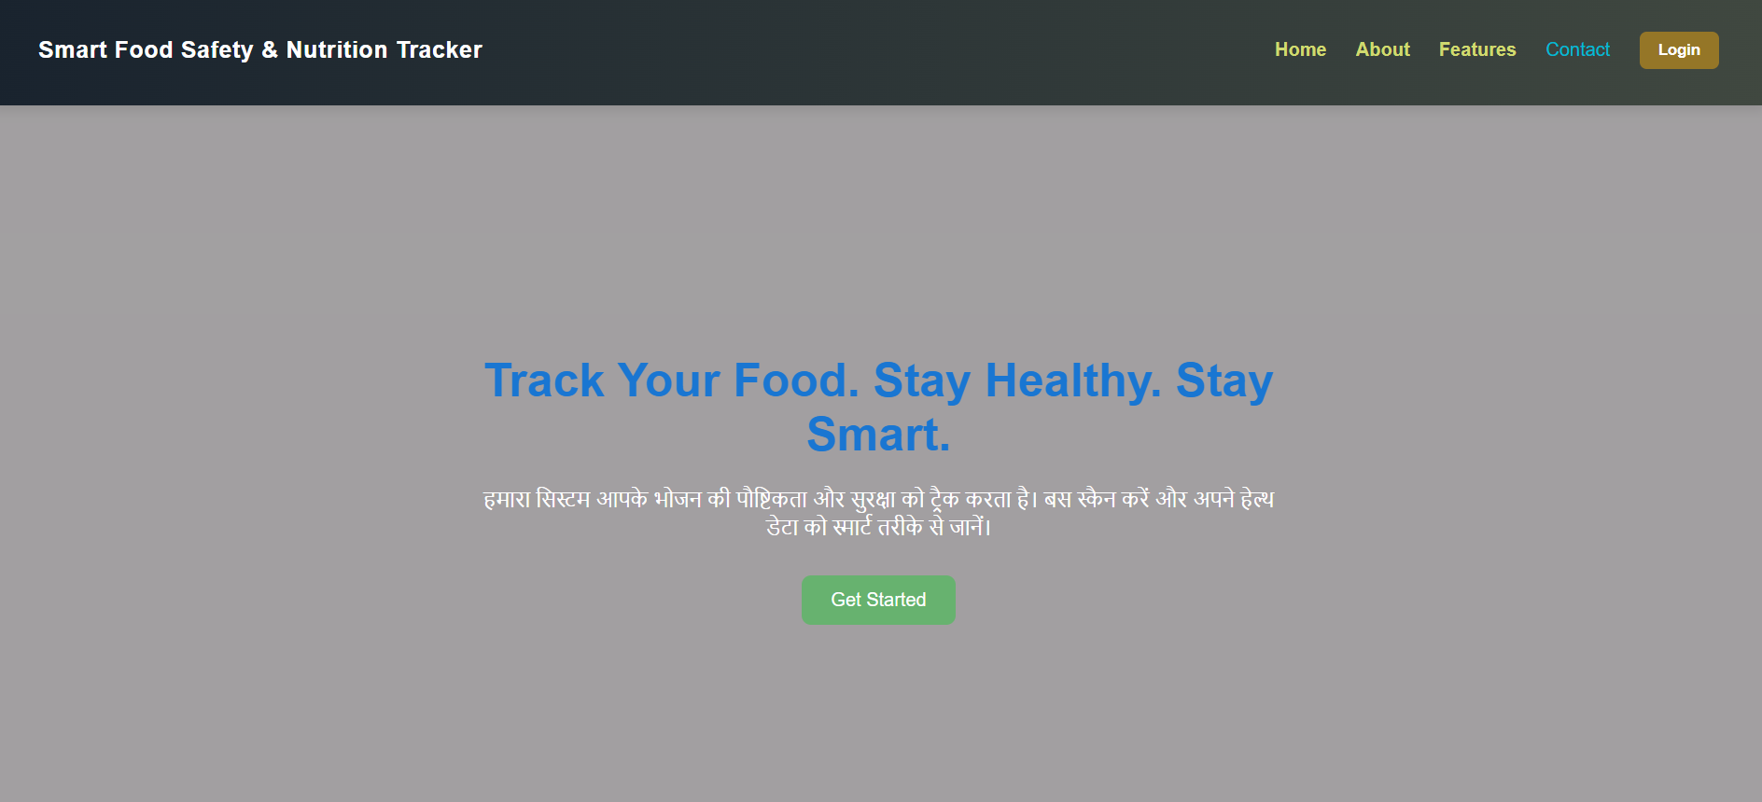
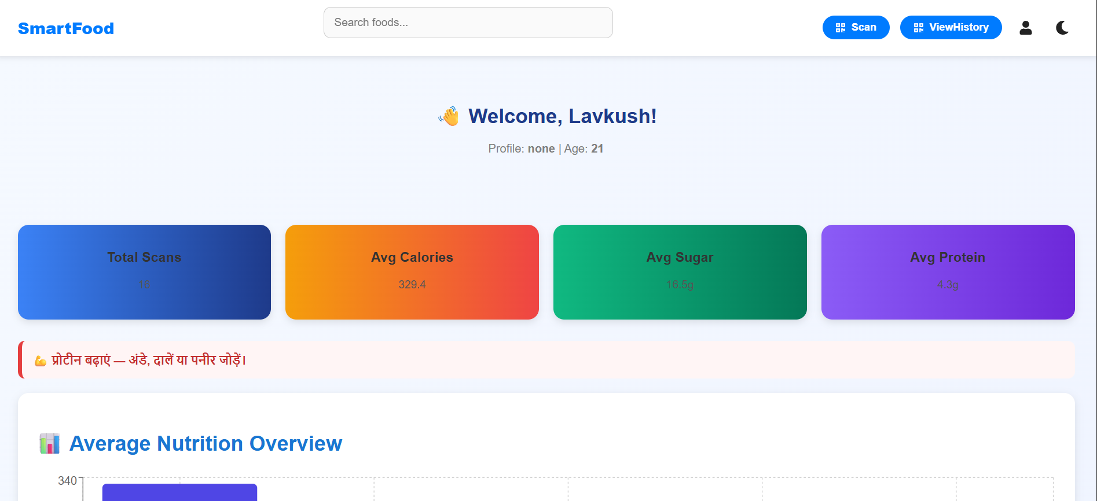

5.4 TESTING TECHNIQUES AND TEST PLANS
Testing ensures that the system works correctly, meets requirements, and is free from errors, improving reliability and performance.

Testing Techniques
- Unit Testing: Tests individual modules (e.g., health score, input validation)
- Integration Testing: Verifies interaction between components (frontend–backend–database)
- System Testing: Tests complete system functionality
- User Acceptance Testing (UAT): Validates the system with real users
- Performance Testing: Checks speed and response time
- Security Testing: Ensures data protection and access control

Sample Test Cases
Test Case | Input | Expected Output
Barcode Scan | Valid barcode | Correct product data
Food Search | "Milk" | List of products
Invalid Input | Random text | Error message
Health Score | High sugar | Low score
Recommendation | Healthy food | “Safe to Consume”

Testing Process
Test Case Design → Execution → Result Comparison → Bug Fixing → Re-testing

CHAPTER 6:
EXPECTED RESULTS AND DISCUSSION

6.1 EXPECTED RESULTS AND DISCUSSION
The system is expected to provide accurate, real-time, and user-friendly information about food products, improving awareness and promoting healthy eating habits.

Expected Results
- Accurate food identification using barcode or search
- Display of key nutritional information (calories, protein, fats, sugar, etc.)
- Detection of harmful ingredients and safety warnings
- Generation of a health score based on nutrition and safety
- Personalised recommendations based on user profile
- Fast response time and user-friendly interface

Discussion
The system improves food awareness by combining nutrition analysis, safety evaluation, and personalised recommendations in a single platform. It helps users make informed decisions and reduces the risk of unhealthy food consumption.
6.2 EXPECTED PERFORMANCE RESULTS
The system performance is evaluated based on speed, accuracy, scalability, and reliability to ensure efficient real-time operation.

Expected Performance
- Fast Response Time: Results generated within 1–3 seconds
- High Accuracy: Reliable nutritional data and health score analysis
- Real-Time Processing: Quick data retrieval and analysis
- Scalability: Supports multiple users and large datasets
- Reliability: Stable system with proper error handling
- Usability: Smooth and responsive user interface
- Security: Safe handling of user data
- Resource Efficiency: Optimized memory and processing usage
CHAPTER 7:
CONCLUSION
7.1 CONCLUSION
The Smart Food Safety and Nutrition Tracker addresses the lack of awareness regarding food quality, nutrition, and safety in modern lifestyles. The system integrates food identification, nutritional analysis, safety evaluation, and personalised recommendations into a single platform.
It enables users to easily access and understand food information through barcode scanning or search, while simplifying complex nutritional data into user-friendly insights. The health score mechanism helps users quickly evaluate food quality, and ingredient analysis improves awareness of harmful substances.
The system also provides personalised recommendations based on user profiles, making it more effective than traditional food tracking applications. The use of modern technologies and modular architecture ensures scalability, efficiency, and real-time performance.
Although the system depends on external data sources, it effectively supports users in making informed dietary decisions and promotes healthier lifestyles.

📚 REFERENCES
[1] Open Food Facts Database, “Food Products Nutrition Dataset,” https://world.openfoodfacts.org/
[2] WHO, “Healthy Diet Guidelines,” World Health Organization, https://www.who.int/
[3] USDA FoodData Central, “Nutritional Information Database,” https://fdc.nal.usda.gov/
[4] P. Harrington, Machine Learning for Health Applications, Springer, 2022.
[5] A. Sharma et al., “Food Nutrition Analysis using AI and Machine Learning,” IEEE Access, 2023.
[6] React Documentation, “Frontend Framework Guide,” https://react.dev/
[7] Node.js Documentation, “Backend Development Guide,” https://nodejs.org/
[8] Flask Documentation, “Python Web Framework,” https://flask.palletsprojects.com/
APPENDICES

Appendix A: Source Code
The complete source code of the Smart Food Safety and Nutrition Tracker project is hosted on GitHub for version control and collaboration.
🔗 GitHub Repository:https://github.com/Lavkush-patel9/Lavkush-patel9-Smart-Food-Safety-Nutrition-Tracker-Web-App
This repository includes:
- Frontend (React.js)
- Backend (Node.js APIs)
- Python Microservices (Nutrition, Safety, Health Score)
- Database integration scripts
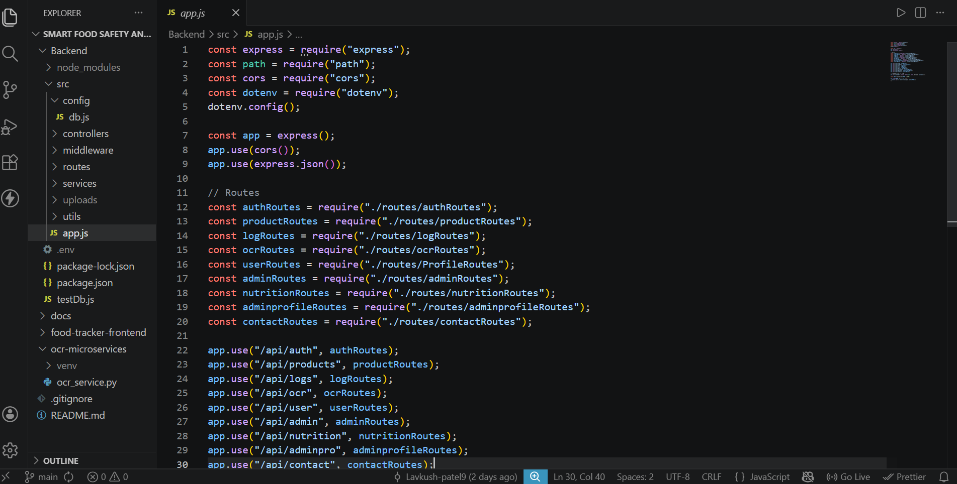
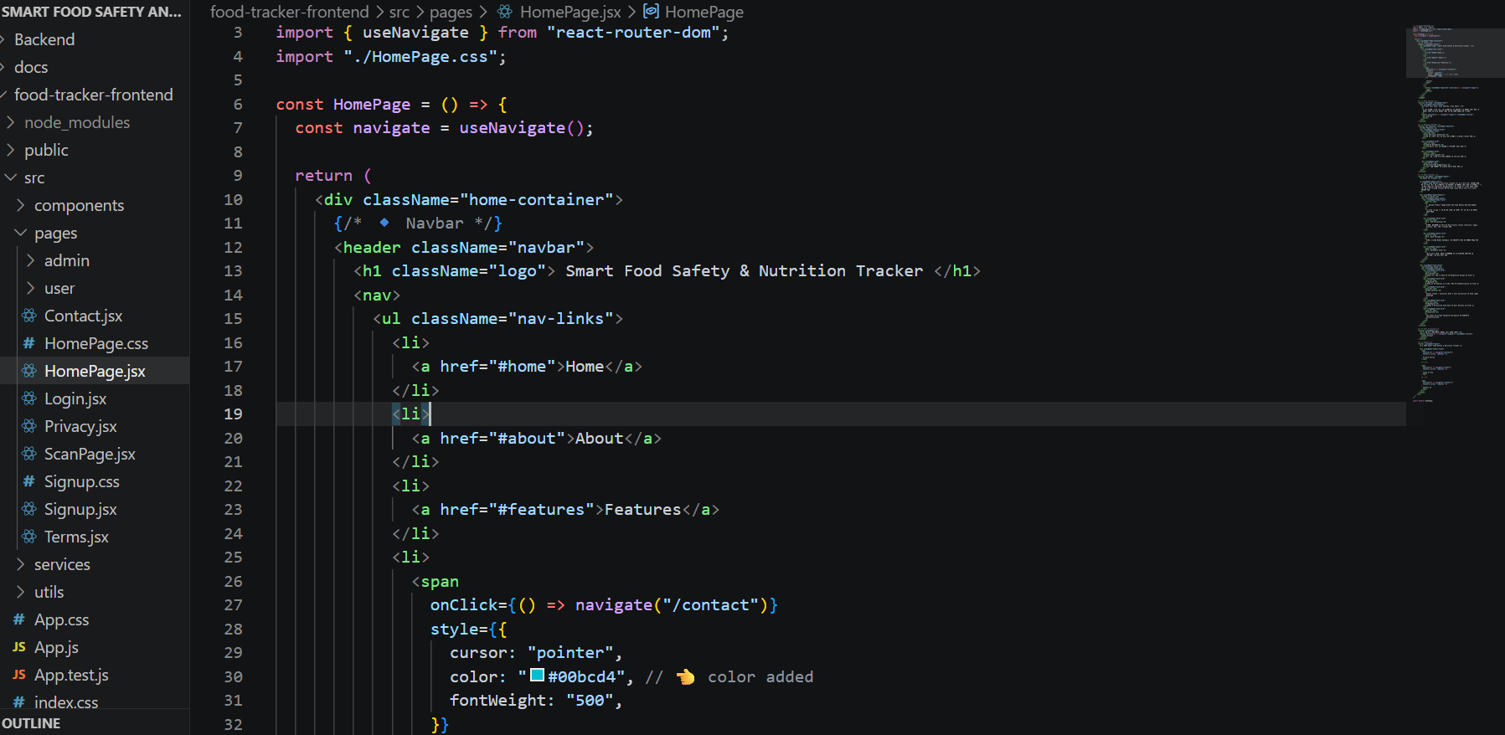

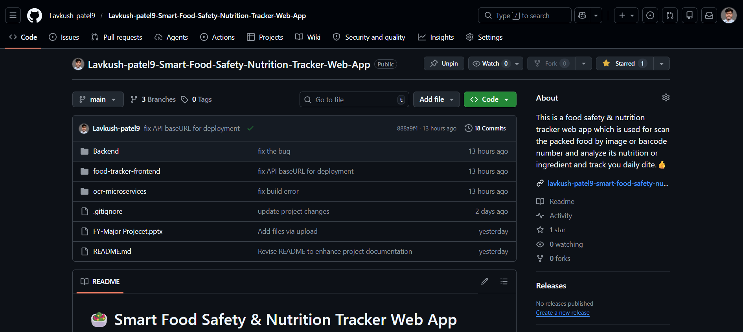

Appendix B: Project Timeline (Gantt Chart)
The project development followed a structured timeline:
- Requirement Analysis
- System Design
- Frontend Development
- Backend Development
- Microservices Integration
- Testing Phase
- Documentation
📊 A Gantt chart illustrates the scheduling and completion phases of tasks.

Appendix C: Team Member Contributions
- Frontend Development: UI design, React components
- Backend Development: Node.js APIs and routing
- Microservices: Python-based nutrition & safety analysis
- Database Design: Schema and data management
- Testing & Documentation: Testing, report writing

Appendix D: Dataset Details and Sources
The system uses structured food datasets, including:
- Open Food Facts Dataset
- USDA FoodData Central
- Manually curated food safety rules dataset
- Ingredient risk classification dataset
These datasets are used for:
- Nutritional analysis
- Health score calculation
- Food safety evaluation

Appendix E: Relevant Published Papers
The project is based on research from the following domains:
- Food Nutrition Analysis using Machine Learning
- AI-based Diet Recommendation Systems
- Barcode-based Food Tracking Systems
- Health Risk Prediction using Data Science
Key references include IEEE research papers, health journals, and AI-based nutrition studies.

